John Michael Go
Career Entry Level Java Programming
Date: Jan. 22, 2013

DAY 8

Program Name: Array9

Objective: Modified program that do descending sort for integer.

Algorithm:

1. Program sorts an integer array in descending order.

Flowchart:

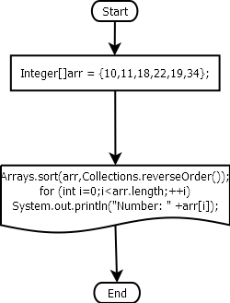

Pseudocode:

import java.util.Arrays;
import java.util.Collections;

public class Array9 {

public static void main(String[] args) {

Integer[]arr = {10,11,18,22,19,34};

Arrays.sort(arr,Collections.reverseOrder());
for (int i=0;i<arr.length;++i)
System.out.println("Number: " +arr[i]);

}

}

Screenshots:

